**DT282 Software for the Global Market 2**

**Phase I**

**Note: You can change the look and feel of this document (fonts, section order, adding sub-sections etc. but you must address all the requirements for content).**

# Group Number: 2

# Group Members:

|  |  |
| --- | --- |
| **Student Number** | **Student Name** |
| C18333703 | Nikolay Malyshev |
| C18416902 | Ireayo Adebari |
| C18420686 | Kyle Butler |
| C18359123 | Raphael Ofeimu |
| C18357323 | Daniel Krasovski |

# Target Area/Scope

*In this section:*

* *State your target area*

***Our target area is Societies and Events***

* *Provide a short description about the scope of the content/functions you intend to address.*

***We intend to create a main page that will direct the user to specific areas in our website (e.g. an overview of the societies, and an events page). We would also include a ‘create a society’ page and a ‘sign up’ page where the user could create their own society or sign up for an existing one.***

* *Make sure this is consistent with your sitemap/architecture when described.*

# Application Architecture/Sitemap

*In this section:*

* *Present a sitemap/application architecture*
* *Allocate responsibility for implementing each distinct section of the site/application to one team member*
* *Make sure this is consistent with your target area/scope when described.*

*Example (for illustration only, you can adopt any style you prefer):*

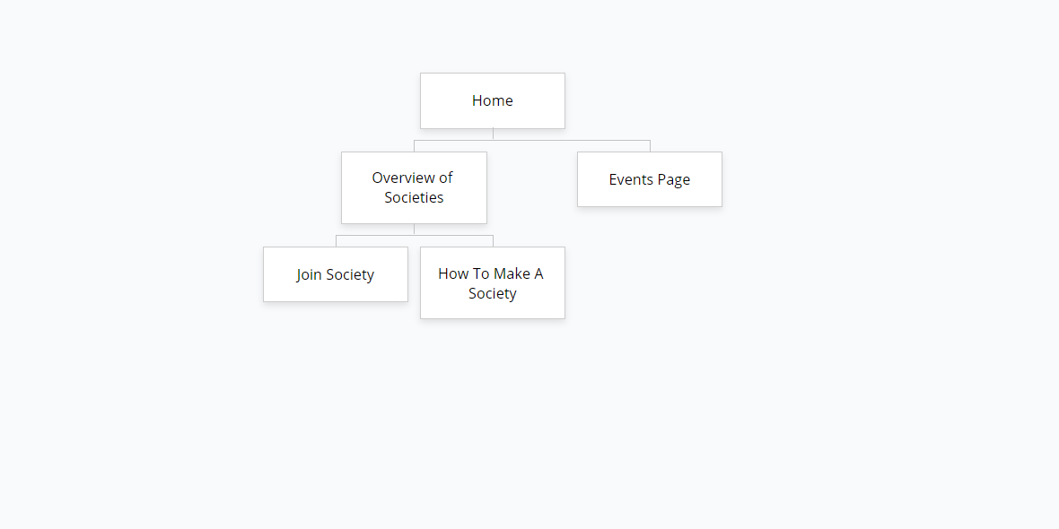

**Ire Adebari –** *Home Page*

**Nikolay Malyshev –** *Events Page*

**Daniel Krasovski –** *Overview of Societies5*

**Raphael Ofiemu –** *Join Society*

**Kyle Butler –** *How To Make A Society*

# Culturalization Decisions

*In this section:*

* *State clearly the cultural dimensions each group member intends to address. (as a group you can decide that each group member is going to address the same two dimensions.)*

***As a group, we have each decided to tackle the following cultural dimensions:***

1. ***Monochronic Vs. Polychronic***
2. ***Universalism Vs. Particularism***

***Monochronic – Particularism***

* ***Changing image-based sections into text-based sections. Changing the layout is also a possibility (e.g. changing the nav bar into a drop-down menu)***
* ***We considered changing the colour-scheme, however seeing as TUDublin uses primarily blue colours on their website, we thought that we would consistently use the same colour.***

***We will use universalism to accommodate a much larger audience, as opposed to particularism which zones in on trying to accommodate a very particular audience.***

# Team Working Mechanisms

*In this section:*

* *Consider key principles of Lean UX and decide working mechanisms which allow you to embrace those that make sense.*
* *State your working mechanisms and which principles of Lean UX they align with and why.*

***The key principles that we have decided to adopt will allow us to maximise efficiency and work smarter as a group.***

1. ***Act as one team – Together we’ll design a website that will satisfy the given specifications. We’ll put our minds together to find out what it is that we know, and what it is that we need to find out.***
2. ***Focus on solving the right problem – Ensuring that we aren’t doing anything unnecessary. It will be at the top of our priority list to meet the requirements we are asked to meet, and ensure that we resolve the problems.***
3. ***Think-Make-Check – We’ll brainstorm on a simple wireframe to use as an outline for our separate webpages. Then we will use GitHub as a medium for relaying and combining information.***
4. ***Permission to fail – Every member of the group will be allowed to be as creative as possible, so long as it follows the restrictions that we were given. We won’t discourage any attempts given by any team member, seeing as every failed attempt is still a successful contribution.***
   * *Examples of things to consider:*
     + *What needs to be communicated to the group by each group member (e.g. discovery, progress, problem, design issue, solution, what we know, what we don’t know, what we intended to do)*
     + *How to communicate with other team members*
     + *How to share work/outcomes*
     + *How to provide feedback on work completed*
     + *How to handle change*
     + *How to capture and share overall progress with the project (what we know/have done, what we don’t know/haven’t done, what we intended do/what we have changed)*

# Lean UX Quick Overview

*Cycle of Think-Make-Learn or Build-Measure-Learn*

*Selected Principles:*

*Act as one team*

*Progress = Outcomes not Output (Minimum Viable Product)*

*Remove waste- Solve the right problem*

*Continuous Discovery (Plans change so plan to change)*

*Small batch size*

*Making over analysis*

*Externalising your work*

*Permission to fail*